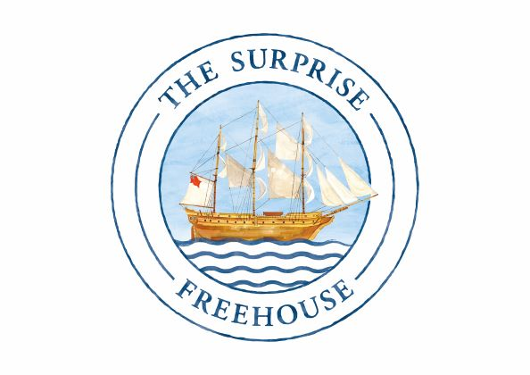

SUNDAY MENU

bloody mary- Sapling vodka, tomato juice, our own house blend of spices £9.5

starters
BUTTERNUT SQUASH soup, wilted rocket, truffle oil, toasted sourdough* (v) £8 / £11
SMOKED MACKEREL AND AVOCADO RILETTES, confit tomatoes, toast £8.5
WILTSHIRE BEEF FILLET CARPACCIO, pickled mushroom, parmesan £10
PARMA HAM, celeriac remoulade, walnut dressing £7.5
HOT SMOKED SALMON, pickled beetroot, horseradish cream £9.5
TENDERSTEM BROCCOLI, egg, anchovy mayo, parmesan £7.5

SUNDAY ROASTS

BEEF SIRLOIN, horseradish cream £19.5
PORK BELLY, crackling, apple sauce £17
LEG OF LAMB, mint sauce £18.5
CHICKEN ON THE BONE, bread sauce - half (for 1person) £16.5

All our roasts are served with roast potatoes, heritage carrots, greens, gravy and Yorkshire pudding

Pan fried seabass fillet, orange carrots, cucumber and shrimp lemon butter sauce £21
WILD MUSHROOM AND TRUFFLE RIGATONI £15

sides
EXTRA ROAST VEGETABLES £5
CHIPS £4
(with truffle oil and parmesan) £4.5
SWEET POTATO FRIES £4

